Robotics
As application of drones

MINI PROJECT
- Robotics is a multidisciplinary field that combines aspects of engineering, computer science, and other scientific disciplines to design, construct, operate, and use robots.
- Robots are automated machines capable of performing tasks autonomously or semi-autonomously, often with the goal of improving efficiency, precision, and safety in various applications.
- Components of Robotics:
- Mechanical Design: Involves creating the physical structure of the robot
- Electronics: Includes the circuitry, sensors, and actuators that enable the robot to interact with its environment.
- Programming: Involves creating the software that controls the robot's behavior and responses.
- Types of Robots:
- Manufacturing: Automation in factories to enhance efficiency and precision.
- Healthcare: Surgical robots, robotic prosthetics, and telepresence robots for patient care.
- Exploration: Use of robots in space exploration and deep-sea exploration.
- Military and Defense: Unmanned aerial vehicles (UAVs), bomb disposal robots, and surveillance robots.
- Challenges in Robotics:
- Sensory Perception: Developing robots that can accurately perceive and interpret their surroundings.
- Human-Robot Interaction: Ensuring safe and effective collaboration between humans and robots.
- Robotics has the potential to revolutionize various industries and improve the quality of life by automating repetitive tasks, enhancing precision, and addressing challenges that may be hazardous or difficult for humans.
- As technology continues to advance, the field of robotics is expected to see continuous growth and innovation.

DRONES
- Drones, also known as Unmanned Aerial Vehicles (UAVs) or
Unmanned Aircraft Systems (UAS), have become increasingly popular for surveying and mapping applications due to their versatility, costeffectiveness, and efficiency.
Aerial Imaging:
- Drones are equipped with high-resolution cameras and sensors that capture aerial imagery.
- Aerial photography and photogrammetry are used to create detailed and accurate maps.

DRONES
Topographic Mapping:
- Drones can be employed to create topographic maps by capturing detailed elevation data.
- This is particularly useful in construction, urban planning, and environmental monitoring.
LiDAR Technology:
- Some advanced drones are equipped with Light Detection and Ranging (LiDAR) sensors.
- LiDAR technology allows for 3D mapping, enabling the creation of detailed terrain models, even in challenging environments

PROJECT
• This drone is designed by using solid edge This basic drone for surveying consists of
- Frame
- Propellers iii. Motors iv. Remote control v. Batteries vi. Camera
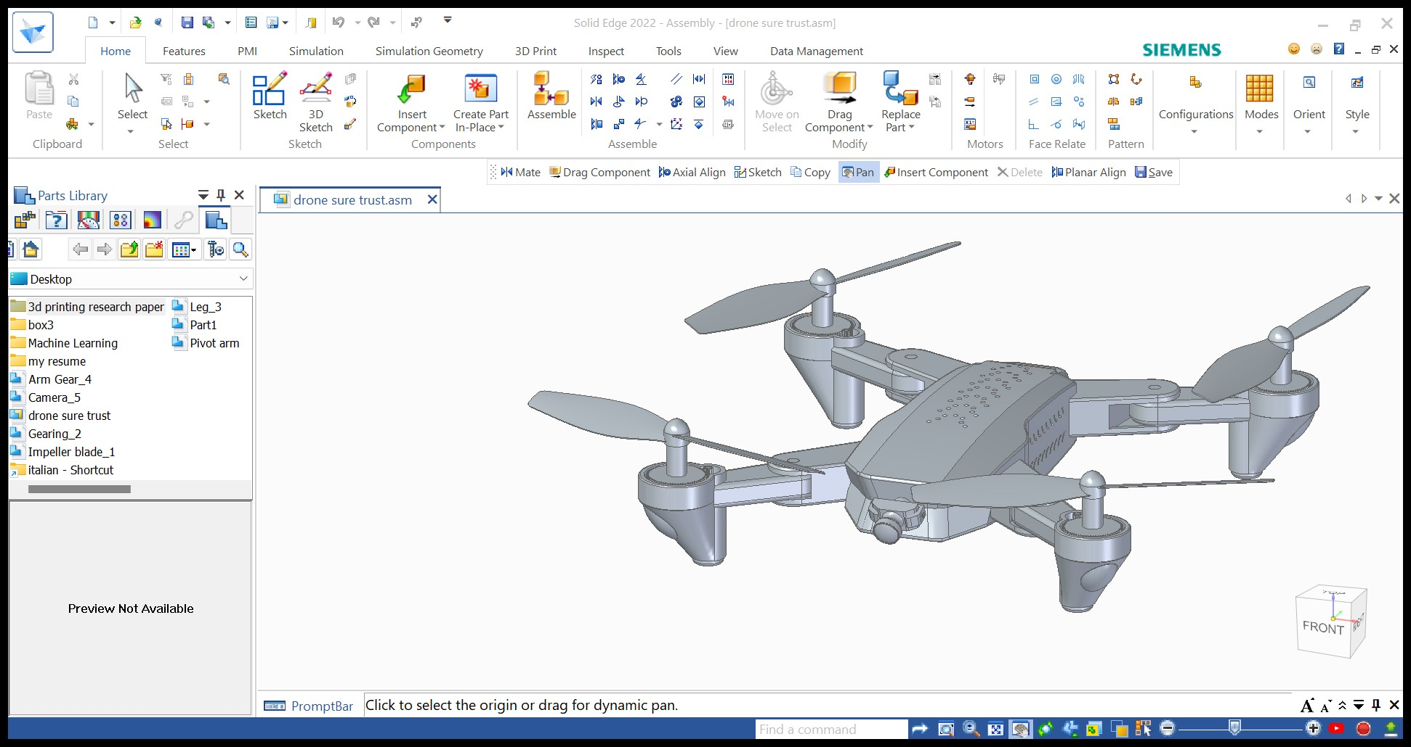
DESIGN

Functions of components
Frame and Structure:
- The frame provides the structural foundation for the drone, supporting the payload and housing the electronic components.
- Lightweight materials like carbon fiber are often used to maximize flight efficiency.
Propulsion System:
- Motors and propellers generate the thrust needed for flight.
- Quadcopters (four rotors), hexacopters (six rotors), and octocopters (eight rotors) are common configurations.

Functions of components
Remote Control or Ground Control Station:
- Pilots use remote controls or ground control stations to operate the drone manually.
- Automated flight planning software is often used for surveying missions.
Camera:
- High-resolution cameras are crucial for capturing detailed imagery.
- Some drones have gimbals for stabilized camera mounting, ensuring clear and sharp images.

Functions of components
Payload:
- The payload includes the sensors and equipment needed for surveying and mapping applications.
- Key components may include cameras, LiDAR sensors, multispectral sensors, or thermal cameras.

THANK YOU

